THERMODYNAMICS
- Thermodynamics is a branch of physics that deals with heat, work, and temperature, and their relation to energy, radiation, and physical properties of matter.
- The behavior of these quantities is governed by the four laws of thermodynamics which convey a quantitative description using measurable macroscopic physical quantities, but may be explained in terms of microscopic constituents by statistical mechanics.
- Thermodynamics applies to a wide variety of topics in science and engineering, especially physical chemistry, chemical engineering and mechanical engineering, but also in other complex fields such as meteorology.
- A thermodynamic system is a body of matter and/or radiation, confined in space by walls, with defined permeabilities, which separate it from its surroundings. The surroundings may include other thermodynamic systems, or physical systems that are not thermodynamic systems. A wall of a thermodynamic system may be purely notional, when it is described as being 'permeable' to all matter, all radiation, and all forces.
- Types of systems: isolated, closed, and open thermodynamic systems.
- An isolated thermodynamic system has walls that are non-conductive of heat and perfectly reflective of all radiation, that are rigid and immovable, and that are impermeable to all forms of matter and all forces. (Some writers use the word 'closed' when here the word 'isolated' is being used.)
- A closed thermodynamic system is confined by walls that are impermeable to matter, but, by thermodynamic operations, alternately can be made permeable (described as 'diathermal') or impermeable ('adiabatic') to heat, and that, for thermodynamic processes (initiated and terminated by thermodynamic operations), alternately can be allowed or not allowed to move, with system volume change or agitation with internal friction in system contents, as in Joule's original demonstration of the mechanical equivalent of heat, and alternately can be made rough or smooth, so as to allow or not allow heating of the system by friction on its surface.
- An open thermodynamic system has at least one wall that separates it from another thermodynamic system, which for this purpose is counted as part of the surroundings of the open system, the wall being permeable to at least one chemical substance, as well as to radiation; such a wall, when the open system is in thermodynamic equilibrium, does not sustain a temperature difference across itself.
- The state of a thermodynamic system is described by thermodynamic state variables, which may be intensive, such as temperature, or pressure, or extensive, such as entropy, or internal energy.
When a system is at equilibrium under a given set of conditions, it is said to be in a definite thermodynamic state. The state of the system can be described by a number of state quantities that do not depend on the process by which the system arrived at its state. They are called intensive variables or extensive variables according to how they change when the size of the system changes. The properties of the system can be described by an equation of state which specifies the relationship between these variables. State may be thought of as the instantaneous quantitative description of a system with a set number of variables held constant.
- Thermodynamic process may be defined as the energetic evolution of a thermodynamic system proceeding from an initial state to a final state. It can be described by process quantities. Typically, each thermodynamic process is distinguished from other processes in energetic character according to what parameters, such as temperature, pressure, or volume, etc., are held fixed; Furthermore, it is useful to group these processes into pairs, in which each variable held constant is one member of a conjugate pair.
Several commonly studied thermodynamic processes are:
Adiabatic process: occurs without loss or gain of energy by heat
Isenthalpic process: occurs at a constant enthalpy
Isentropic process: a reversible adiabatic process, occurs at a constant entropy
Isobaric process: occurs at constant pressure
Isochoric process: occurs at constant volume (also called isometric/isovolumetric)
Isothermal process: occurs at a constant temperature
Steady state process: occurs without a change in the internal energy
- Intensive and extensive properties: Physical properties of materials and systems can often be categorized as being either intensive or extensive, according to how the property changes when the size (or extent) of the system changes. According to IUPAC, an intensive quantity is one whose magnitude is independent of the size of the system^{[1]} whereas an extensive quantity is one whose magnitude is additive for subsystems.^{[2]} This reflects the corresponding mathematical ideas of mean and measure, respectively.
An intensive property is a bulk property, meaning that it is a local physical property of a system that does not depend on the system size or the amount of material in the system. Examples of intensive properties include temperature, T; refractive index, n; density, ρ; and hardness of an object, η. By contrast, extensive properties such as the mass, volume and entropy of systems are additive for subsystems because they increase and decrease as they grow larger and smaller, respectively.
An intensive property is a physical quantity whose value does not depend on the amount of the substance for which it is measured. For example, the temperature of a system in thermal equilibrium is the same as the temperature of any part of it. If the system is divided by a wall that is permeable to heat or to matter, the temperature of each subsystem is identical; if a system divided by a wall that is impermeable to heat and to matter, then the subsystems can have different temperatures. Likewise for the density of a homogeneous system; if the system is divided in half, the extensive properties, such as the mass and the volume, are each divided in half, and the intensive property, the density, remains the same in each subsystem. Additionally, the boiling point of a substance is another example of an intensive property. For example, the boiling point of water is 100 °C at a pressure of one atmosphere, which remains true regardless of quantity.
The distinction between intensive and extensive properties has some theoretical uses. For example, in thermodynamics, the state of a simple compressible system is completely specified by two independent, intensive properties, along with one extensive property, such as mass. Other intensive properties are derived from those two intensive variables.
Examples of intensive properties include:
- chemical potential, μ
- color
- concentration, c
- density, ρ (or specific gravity)
- magnetic permeability, μ
- melting point and boiling point
- molality, m or b
- pressure, p
- refractive index
- Specific conductance (or electrical conductivity)
- specific heat capacity, c_{p}
- specific internal energy, u
- specific rotation, [α]
- specific volume, v
- standard reduction potential, E°
- surface tension
- temperature, T
- thermal conductivity
- viscosity
An extensive property is a physical quantity whose value is proportional to the size of the system it describes, or to the quantity of matter in the system. For example, the mass of a sample is an extensive quantity; it depends on the amount of substance. The related intensive quantity is the density which is independent of the amount. The density of water is approximately 1g/mL whether you consider a drop of water or a swimming pool, but the mass is different in the two cases.
Dividing one extensive property by another extensive property generally gives an intensive value—for example: mass (extensive) divided by volume (extensive) gives density (intensive).
- State function, function of state, or point function is a function defined for a system relating several state variables or state quantities that depends only on the current equilibrium thermodynamic state of the system (e.g. gas, liquid, solid, crystal, or emulsion), not the path which the system took to reach its present state. A state function describes the equilibrium state of a system, thus also describing the type of system. For example, a state function could describe an atom or molecule in a gaseous, liquid, or solid form; a heterogeneous or homogeneous mixture; and the amounts of energy required to create such systems or change them into a different equilibrium state. Internal energy, enthalpy, and entropy are examples of state quantities because they quantitatively describe an equilibrium state of a thermodynamic system, regardless of how the system arrived in that state. Generally, a state function is of the form , where P denotes pressure, T denotes temperature, V denotes volume, and the ellipsis denotes other possible state variables like particle number N and entropy S. If the state space is two-dimensional as in the above example, it can be visualized as a three-dimensional graph (a surface in three-dimensional space). However, the labels of the axes are not unique (since there are more than three state variables in this case), and only two independent variables are necessary to define the state.
State functions represent quantities or properties of a thermodynamic system, while non-state functions represent a process during which the state functions change. For example, the state function PV is proportional to the internal energy of an ideal gas, but the work W is the amount of energy transferred as the system performs work. Internal energy is identifiable; it is a particular form of energy. Work is the amount of energy that has changed its form or location.
The following are considered to be state functions in thermodynamics:
- Mass  - Energy (E)  - Enthalpy (H)  - Internal energy (U)  - Gibbs free energy (G)  - Helmholtz free energy (F)  - Exergy (B)  - Entropy (S) | - Pressure (P)  - Temperature (T)  - Volume (V)  - Chemical composition  - Specific volume (v) or its reciprocal density (ρ)  - Altitude  - Particle number (n_{i})
- Path function: When a system changes state continuously, it traces out a "path" in the state space. The path can be specified by noting the values of the state parameters as the system traces out the path, whether as a function of time or a function of some other external variable. For example, having the pressure P(t) and volume V(t) as functions of time from time t₀ to t₁ will specify a path in two-dimensional state space. Any function of time can then be integrated over the path. For example, to calculate the work done by the system from time t₀ to time t₁, calculate . In order to calculate the work W in the above integral, the functions P(t) and V(t) must be known at each time t over the entire path. In contrast, a state function only depends upon the system parameters' values at the endpoints of the path. For example, the following equation can be used to calculate the work plus the integral of V dP over the path:
In the equation, the integrand can be expressed as the exact differential of the function P(t)V(t). Therefore, the integral can be expressed as the difference in the value of P(t)V(t) at the end points of the integration. The product PV is therefore a state function of the system.
The notation d will be used for an exact differential. In other words, the integral of dΦ will be equal to Φ(t₁) − Φ(t₀). The symbol δ will be reserved for an inexact differential, which cannot be integrated without full knowledge of the path. For example, δW = PdV will be used to denote an infinitesimal increment of work.
A quantity that is well defined so as to describe the path of a process through the equilibrium state space of a thermodynamic system is termed a process function,^{[1]} or, alternatively, a process quantity, or a path function. As an example, mechanical work and heat are process functions because they describe quantitatively the transition between equilibrium states of a thermodynamic system.
Path functions depend on the path taken to reach one state from another. Different routes give different quantities. Examples of path functions include work, heat and arc length. In contrast to path functions, state functions are independent of the path taken.
- Branches of thermodynamics
The study of thermodynamical systems has developed into several related branches, each using a different fundamental model as a theoretical or experimental basis, or applying the principles to varying types of systems.
  - Classical thermodynamics
  - Statistical mechanics
  - Chemical thermodynamics
  - Equilibrium thermodynamics
  - Non-equilibrium thermodynamics
Classical thermodynamics is the description of the states of thermodynamic systems at near-equilibrium, that uses macroscopic, measurable properties. It is used to model exchanges of energy, work and heat based on the laws of thermodynamics. The qualifier classical reflects the fact that it represents the first level of understanding of the subject as it developed in the 19th century and describes the changes of a system in terms of macroscopic empirical (large scale, and measurable) parameters. A microscopic interpretation of these concepts was later provided by the development of statistical mechanics.
Statistical mechanics, also called statistical thermodynamics, emerged with the development of atomic and molecular theories in the late 19th century and early 20th century, and supplemented classical thermodynamics with an interpretation of the microscopic interactions between individual particles or quantum-mechanical states. This field relates the microscopic properties of individual atoms and molecules to the macroscopic, bulk properties of materials that can be observed on the human scale, thereby explaining classical thermodynamics as a natural result of statistics, classical mechanics, and quantum theory at the microscopic level.
Chemical thermodynamics is the study of the interrelation of energy with chemical reactions or with a physical change of state within the confines of the laws of thermodynamics.
Equilibrium thermodynamics is the study of transfers of matter and energy in systems or bodies that, by agencies in their surroundings, can be driven from one state of thermodynamic equilibrium to another. The term 'thermodynamic equilibrium' indicates a state of balance, in which all macroscopic flows are zero; in the case of the simplest systems or bodies, their intensive properties are homogeneous, and their pressures are perpendicular to their boundaries. In an equilibrium state there are no unbalanced potentials, or driving forces, between macroscopically distinct parts of the system. A central aim in equilibrium thermodynamics is: given a system in a well-defined initial equilibrium state, and given its surroundings, and given its constitutive walls, to calculate what will be the final equilibrium state of the system after a specified thermodynamic operation has changed its walls or surroundings.
Non-equilibrium thermodynamics is a branch of thermodynamics that deals with systems that are not in thermodynamic equilibrium. Most systems found in nature are not in thermodynamic equilibrium because they are not in stationary states, and are continuously and discontinuously subject to flux of matter and energy to and from other systems. The thermodynamic study of non-equilibrium systems requires more general concepts than are dealt with by equilibrium thermodynamics. Many natural systems still today remain beyond the scope of currently known macroscopic thermodynamic methods.
- Endothermic reactions
Those reactions in which heat is absorbed are called endothermic reactions.
e.g., N2​(g)+O2​(g)→2NO(g)−180.7kJ
Energy is being given in this reaction, therefore, it is an endothermic reaction
- Exothermic reactions
Those reactions which are accompanied by the evolution of heat are known as exothermic reactions.
C(s)+O2​(g)→CO2​(g)ΔH=−393.5kJ
Change in enthalpy is negative. Heat is released in this reaction, therefore, it is an exothermic reaction.
- Graphical representation of basic thermodynamic processes
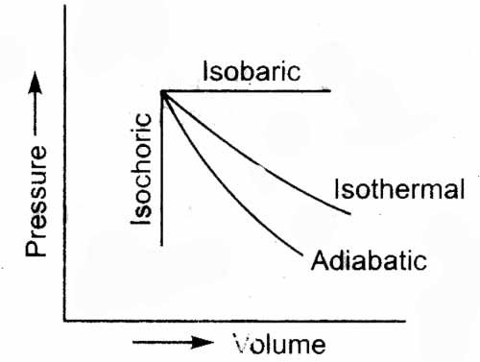

- Reversible and irreversible processes
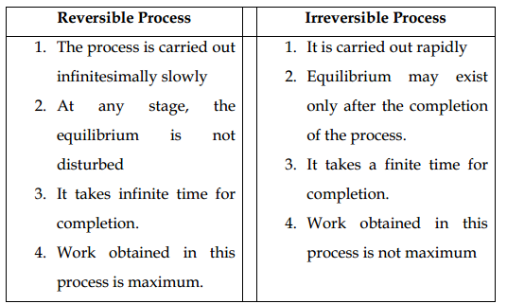
- Work
One definition of energy is the capacity to do work. There are many kinds of work, including mechanical work, electrical work, and work against a gravitational or a magnetic field. Here we will consider only mechanical work and focus on the work done during changes in the pressure or the volume of a gas.
Types of work:
- Electrical work
- Pressure-volume work
- Work done in isothermal reversible expansion
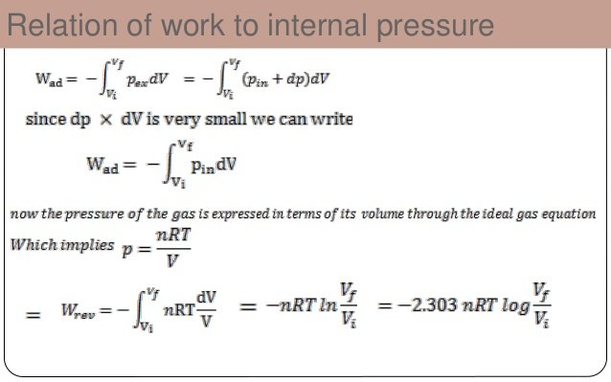
Consider an ideal gas confined in a cylinder with a frictionless piston. The reversible expansion of gas takes place in a finite number of infinitesimally small intermediate steps. If the Pext​ is infinitesimally less than internal pressure of gas P by dP. Then gas expands reversibly and piston moves through a distance dl. Since dP is so small, for all practical purposes. Pext​−Pgas​=P
One work done by gas in one infinitesimal step (dw) can be expressed as; dw = PdV
If the gas expands from V1 to V2 during isothermal reversible expansion. The total amount of work done would be equal to
- Work done in isothermal reversible expansion and irreversible expansion
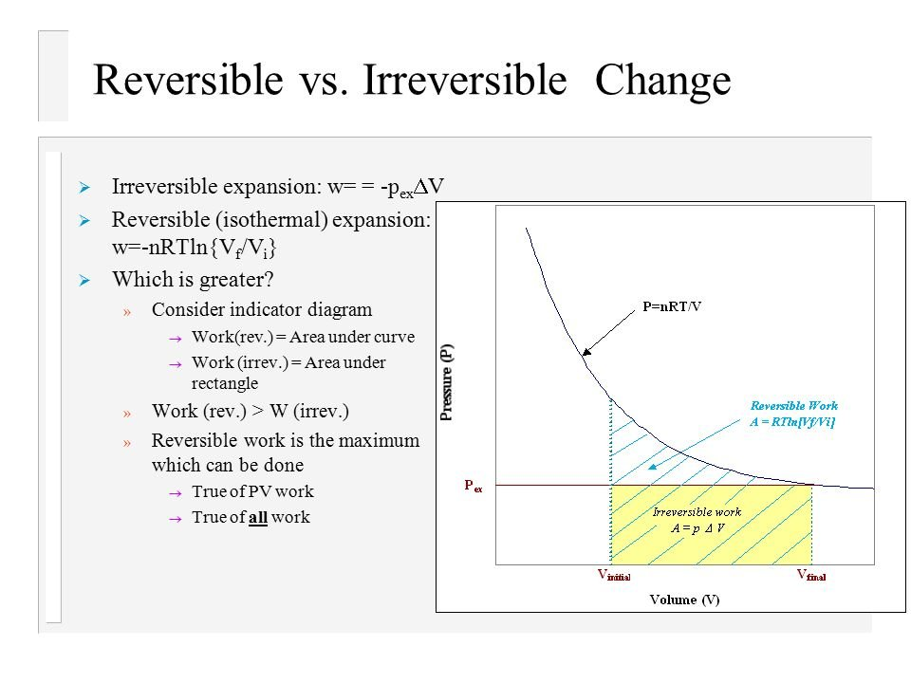
In irreversible expansion, the external pressure remains constant but in reversible expansion, external pressure has to be decreased continuously so as to remain infinitesimally smaller than the internal pressure.
Wrev​>Wirr​
- Heat and its sign convention
It is mode of energy exchanged between the system and the surroundings as a result of the difference of temperature between them. It is usually represented by the letter q. When the heat is given by the system to the surroundings, it is given a negative sign. When the heat is absorbed by the system from the surroundings, it is given a positive sign. Units of heat are calorie, joule.
1 cal = 4.2 J
- Condition for maximum work done
The maximum work that the system can do on the surroundings in an isothermal expansion of an ideal gas is obtained if the expansion is carried out reversibly.
- Expression for maximum work
An expression for the maximum work obtainable from the isothermal reversible expansion of a gas obeying the van der Waals equation of state, Using your expression, calculate how much work is done by one mole of carbon dioxide gas at a temperature T = 300.0K expanding from V_i = 10.00
- Energy and work
Work is the quantity of energy transferred from one system to another without an accompanying transfer of entropy.
- In thermodynamics, a reversible process is a process whose direction can be "reversed" by inducing infinitesimal changes to some property of the system via its surroundings, while not increasing entropy. Throughout the entire reversible process, the system is in thermodynamic equilibrium with its surroundings.
- Laws of thermodynamics

Thermodynamics is principally based on a set of four laws which are universally valid when applied to systems that fall within the constraints implied by each. In the various theoretical descriptions of thermodynamics these laws may be expressed in seemingly differing forms, but the most prominent formulations are the following.
  - Zeroth Law: The zeroth law of thermodynamics states: If two systems are each in thermal equilibrium with a third, they are also in thermal equilibrium with each other.

This statement implies that thermal equilibrium is an equivalence relation on the set of thermodynamic systems under consideration. Systems are said to be in equilibrium if the small, random exchanges between them (e.g. Brownian motion) do not lead to a net change in energy. This law is tacitly assumed in every measurement of temperature. Thus, if one seeks to decide whether two bodies are at the same temperature, it is not necessary to bring them into contact and measure any changes of their observable properties in time.^{[25]} The law provides an empirical definition of temperature, and justification for the construction of practical thermometers.
The zeroth law was not initially recognized as a separate law of thermodynamics, as its basis in thermodynamical equilibrium was implied in the other laws. The first, second, and third laws had been explicitly stated already, and found common acceptance in the physics community before the importance of the zeroth law for the definition of temperature was realized. As it was impractical to renumber the other laws, it was named the zeroth law.
  - First Law
The first law of thermodynamics states: In a process without transfer of matter, the change in internal energy, ΔU, of a thermodynamic system is equal to the energy gained as heat, Q, less the thermodynamic work, W, done by the system on its surroundings.
For processes that include transfer of matter, a further statement is needed: With due account of the respective fiducial reference states of the systems, when two systems, which may be of different chemical compositions, initially separated only by an impermeable wall, and otherwise isolated, are combined into a new system by the thermodynamic operation of removal of the wall, then
,
where U₀ denotes the internal energy of the combined system, and U₁ and U₂ denote the internal energies of the respective separated systems.
Adapted for thermodynamics, this law is an expression of the principle of conservation of energy, which states that energy can be transformed (changed from one form to another), but cannot be created or destroyed.^{[27]}
Internal energy is a principal property of the thermodynamic state, while heat and work are modes of energy transfer by which a process may change this state. A change of internal energy of a system may be achieved by any combination of heat added or removed and work performed on or by the system. As a function of state, the internal energy does not depend on the manner, or on the path through intermediate steps, by which the system arrived at its state.

