Chapter 10 Lecture Notes: Carboxylic Acids, Amines, and Amides

Educational Goals
- Given the structure of a carboxylic acid, carboxylate ion, ester, amide, or amine molecule, be able to give the systemic names and vice versa.
- Know and understand the intermolecular forces that attract carboxylic acid, amine, or amide molecules to one another, and how these forces affect boiling points and melting points.
- Identify amines as primary (1º), secondary (2º), or tertiary (3º). Compare and contrast amines

and quaternary ammonium ions.
- Predict the products for the reactions of carboxylic acids with water, alcohols, amines, ammonia, or with strong bases.
- Predict the products for the reactions of amines with water or with strong acids.
- Predict the products for the base-catalyzed hydrolysis of an ester.
- Predict the products for the acid-catalyzed hydrolysis of an amide.
- Identify chiral carbon atoms in structural formulas. Given the number of chiral carbons in a molecule, determine the number of stereoisomers.
- Define the term enantiomer. Compare and contrast enantiomers and diastereomers.

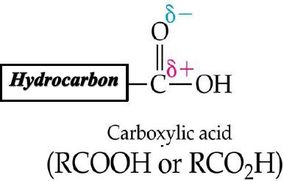
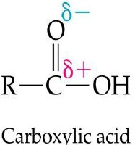
Carboxylic Acids

From now on, we will write “R” instead of “Hydrocarbon” in structures.

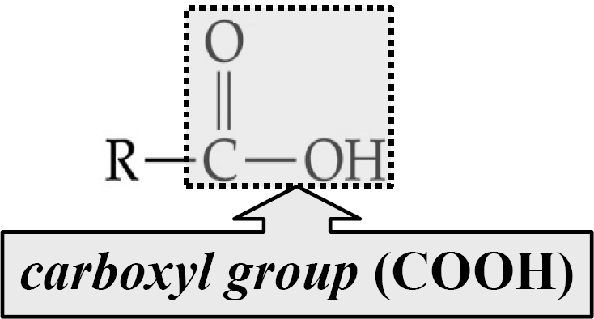
Naming Carboxylic Acids

- When naming a carboxylic acid according to the IUPAC rules, the parent is the longest continuous carbon chain
that the

.

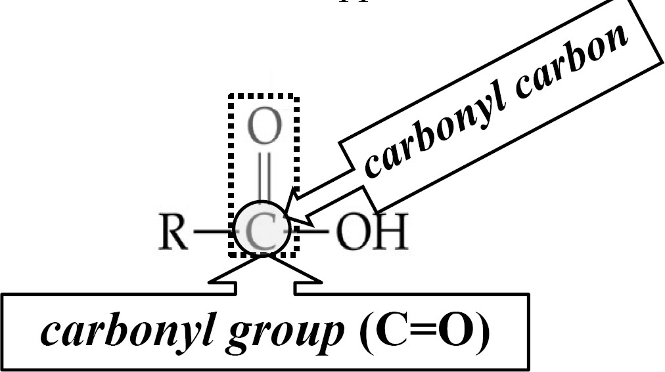
  - Numbering at
the carbonyl carbon, and alkyl groups are identified by name, position, and number of appearances

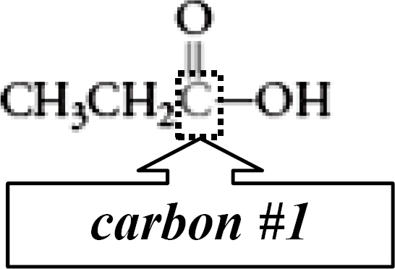
- Example:

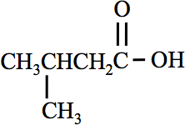
- IUPAC names for carboxylic acid parent chains are formed by dropping the final “e” on the name of the corresponding hydrocarbon and adding “ ”.

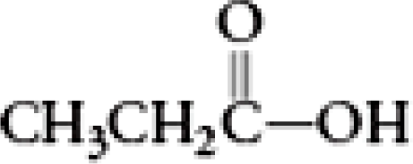
propanoic acid 3-methylbutanoic acid

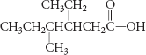
You try it:

Name:
Draw structures of each the carboxylic acids:
a. 2-methylpentanoic acid
b. 4-ethylhexanoic acid

Some carboxylic acids use common names:
methanoic acid = formic acid
ethanoic acid = acetic acid (vinegar is a 5% acetic acid solution)
Group work: Draw each molecule.
NOTE: When named as a substituent, -OH is hydroxy, -Cl is chloro, and -Br is bromo.

butanoic acid b. 2-hydroxypropanoic acid

c. 4-chlorohexanoic acid d. 2-chloro-3-hydroxydecanoic acid

2

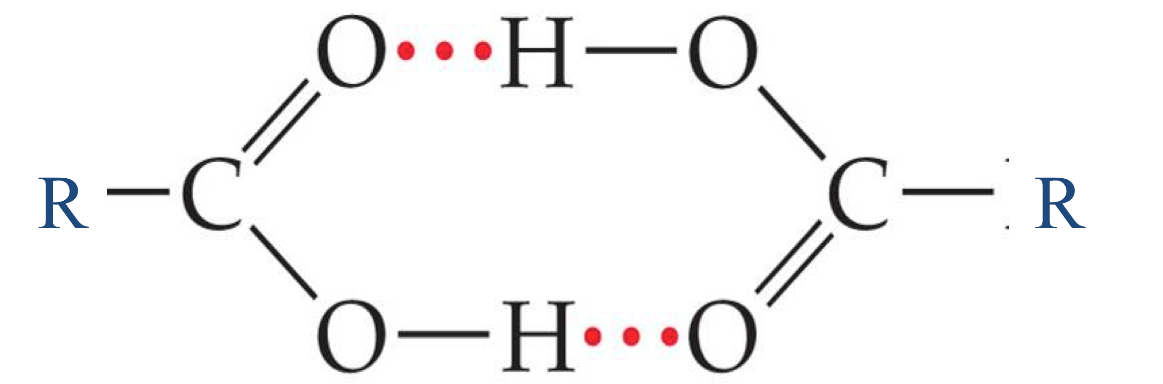
Properties of Carboxylic Acids

- Compared to other organic compounds with a similar molecular weight, carboxylic acids have
relatively high boiling points due to their ability to form
with one another.

- The ability to form hydrogen bonds, in addition to the presence of polar C=O, C-O, and O-H bonds, gives small carboxylic acids a significant water .

- An increasing number of carbon atoms leads to a in water solubility.

Molecule  Name | Condensed Structure | Water Solubility  (g/100 mL)
methanoic  acid | HCOOH | miscible*
ethanoic acid | CH3COOH | miscible
propanoic acid | CH3CH2COOH | miscible
butanoic acid | CH3CH2CH2COOH | miscible
pentanoic acid | CH3CH2CH2CH2COOH | 3.7
hexanoic acid | CH3CH2CH2CH2CH2COOH | 1.0

Common Carboxylic Acids

Formic acid, HCOOH: Chemical that is present in the sting of ants.
Acetic acid, CH₃COOH: dilute (5%) aqueous acetic acid is known as vinegar Butyric acid, CH₃CH₂CH₂COOH: Chemical responsible for odor of rancid butter.
Caproic acid, CH₃CH₂CH₂CH₂CH₂COOH: First isolated from the skin of goats-which has distinct smell. Citric acid: Present in citrus fruits and blood.

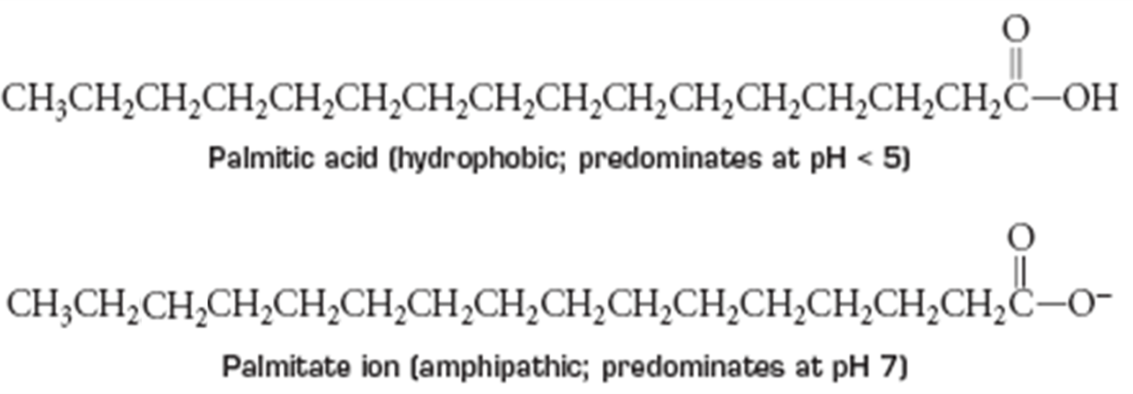
Reactions of Carboxylic Acids

Reaction with Water

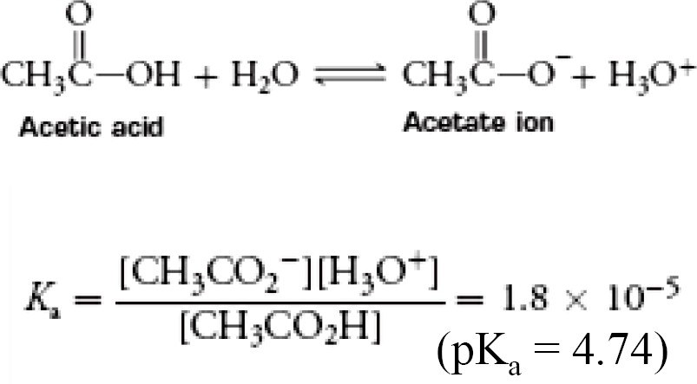
Carboxylic acids are .

  - Acid strengths of common carboxylic acids are about the same as that for acetic acid.

Remember this from chapter 9?

- For the acid (HA) and its conjugate base (A⁻),
HA + H₂O A⁻ + H₃O⁺
- There is more HA when the pH is lower than the pK_{a}.
- There is more A⁻ when the pH is higher than the pK_{a}.
- There are equal amounts of HA and A⁻ when the pH = pK_{a}

Neutralization: Reaction with OH⁻
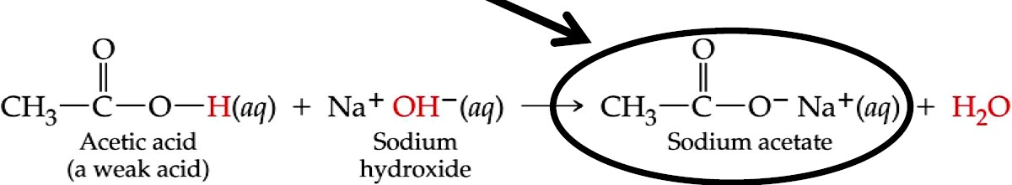
Carboxylic acids undergo with bases and produce water and a carboxylic acid salt.

- The resulting carboxylate ions are in water than the carboxylic acids themselves.
  - The ions have a full charge = more water soluble.

Solubility of Carboxylate Ions
In general, carboxylate anions with 12 or more carbon atoms, like palmitate ion, are , while those with fewer than 12 carbon atoms are water soluble.

Summary: Solubility of Carboxylic Acids and their Conjugate Bases
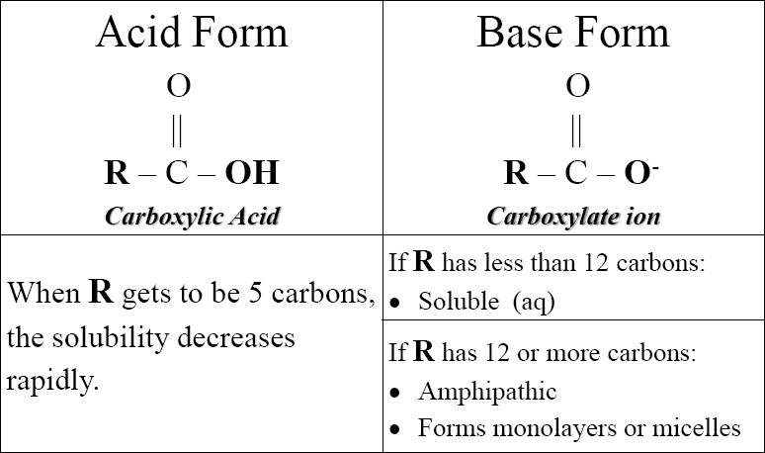

Naming Carboxylate Ions

- To name a carboxylate ion, the ending on the name (IUPAC or common) of the related carboxylic acid is changed from “ic acid” to “ate”.

- Example:
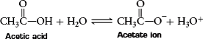
– acetic acid becomes acetate ion

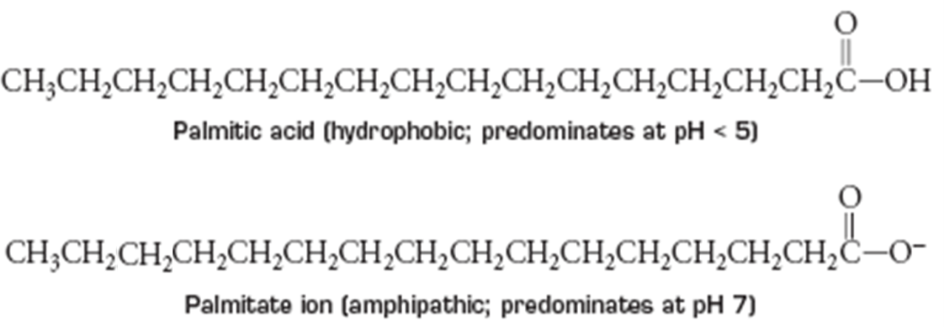
- Palmitic acid becomes palmitate ion

You try it:
Draw and name the conjugate base (carboxylate ion) for the following carboxylic acids:

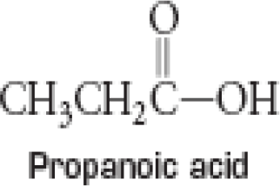

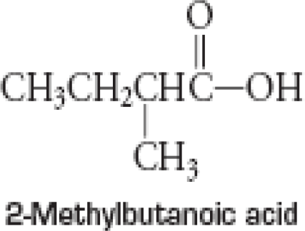

Other Reactions of Carboxylic Acids

- Esterification
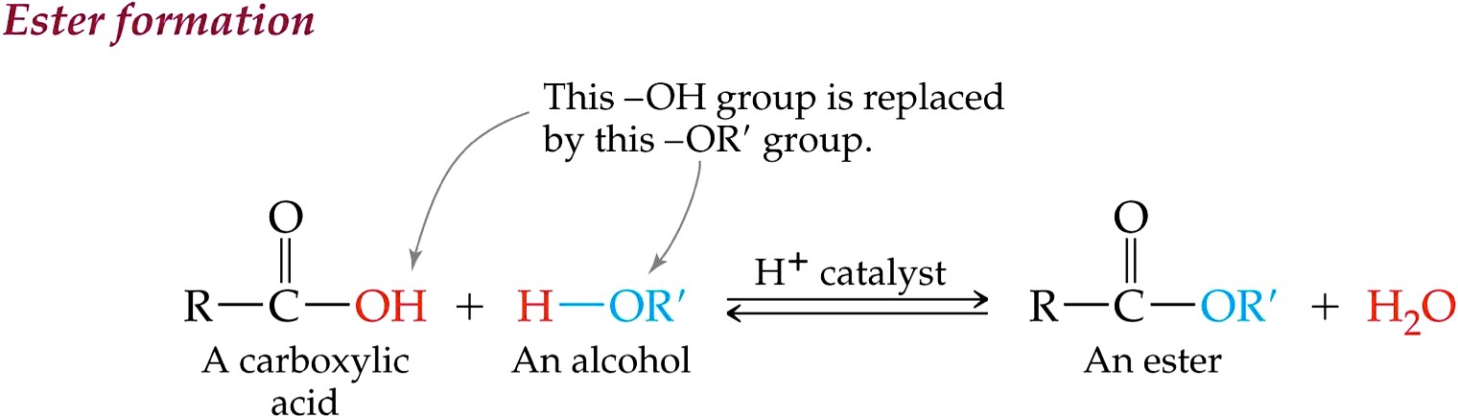
- Esterification is carried out by warming a mixture of a carboxylic acid and an alcohol in the presence of a strong acid catalyst.
Note that the reaction is reversible!
Esters undergo hydrolysis to give back the carboxylic acid.

– we saw this in chapter 6!
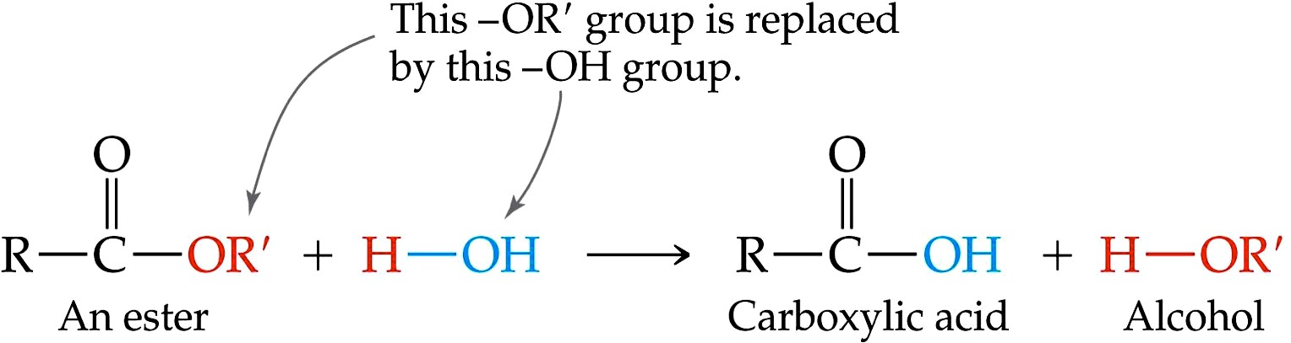
Ester hydrolysis reactions can be catalyzed by either an acid or a base. Here is the net result:

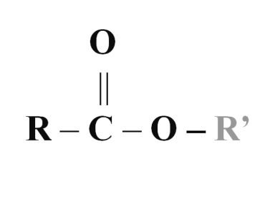
Naming Esters

- When naming an ester, place the name of the alkyl group (R’) in front of the name of the carboxylate part (RCOO) as follows:

Example:

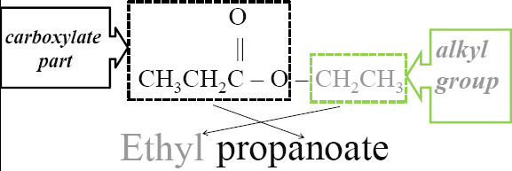
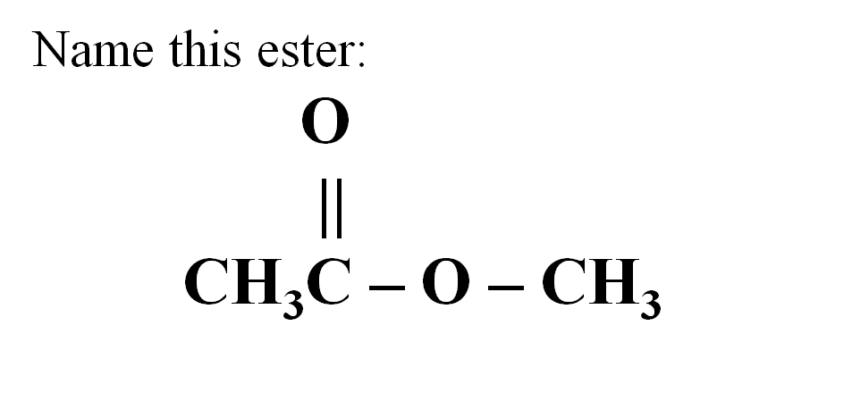
You try it:

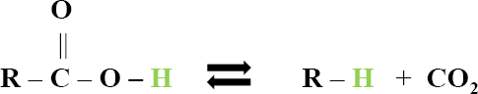
- Decarboxylation of Carboxylic Acids

Break the COOH off, and replace the H!

- Common in biological systems for keto-acids
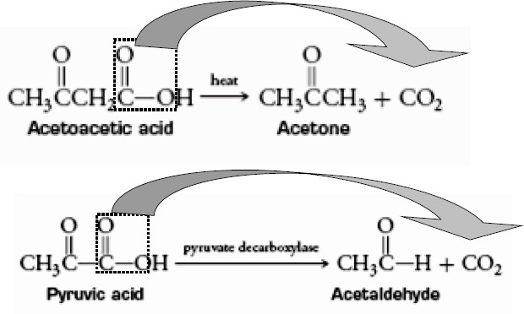
  - Keto acids are carboxylic acids with ketone functionality (carbonyl groups)

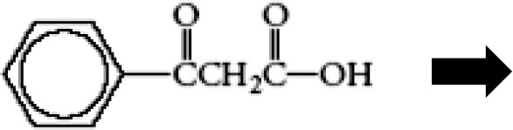
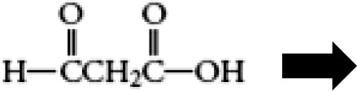
You Try It! Draw the products of each decarboxylation reaction.

Summary of Reactions of Carboxylic Acids:

Reaction with water:

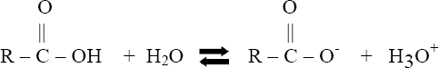

- Neutralization (reaction with OH⁻):

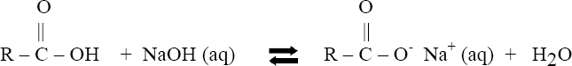

- Esterification (reaction with alcohol):

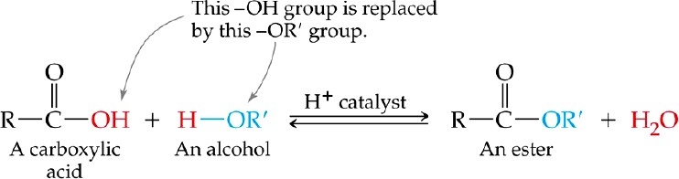

- Decarboxylation:

Amines

are compounds that contain one or more organic groups bonded to nitrogen.

  - They are classified as primary, secondary, and tertiary according to how many are bonded to the nitrogen atom.
    - primary (1°) - only one organic group (R) is attached to the amine nitrogen atom
    - secondary (2°) - two organic groups attached to the amine nitrogen
    - tertiary (3°) - three organic groups attached to the amine nitrogen
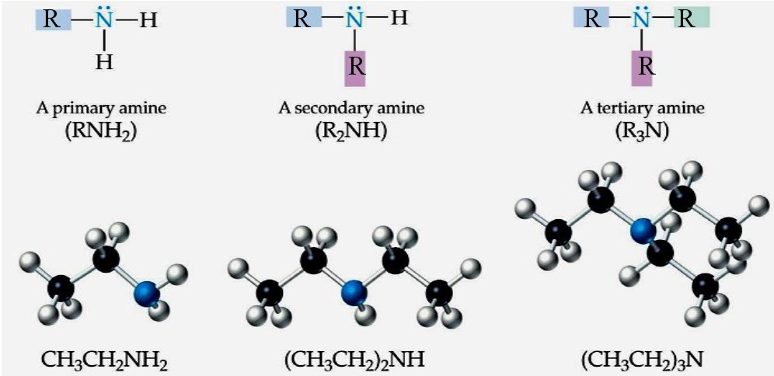

In a primary, secondary, or tertiary amine, the amine nitrogen has a of electrons.

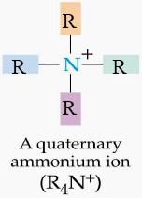
When a fourth group bonds to the nitrogen, the product is a quaternary ammonium ion, which has a

charge and forms ionic compounds.

      - The nitrogen carries a +1 charge.

Naming Amines
- To name a 1°, 2°, or 3° amine using IUPAC rules, the parent, the longest chain of carbon atoms attached to the amine nitrogen atom, is numbered from the end nearer the point of attachment of the nitrogen.
- The parent chains of amines are named by dropping “e” from the name of the corresponding hydrocarbon and adding “amine.”
- Write the carbon number of the point of attachment to the nitrogen in front of the parent name.
  - CH₃CH₂CH₂NH₂ = 1-propanamine

  - CH₃CHCH₃ = 2-propanamine
│
NH₂
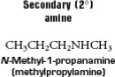
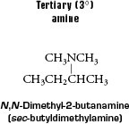
  - If an amine is 2° or 3°, the carbon-containing groups attached to the nitrogen atom that are not part of the parent chain are substituents and N is used to indicate their location (N-methyl, N,N- diethyl, etc.).
  - Simple amines, those with a relatively few number of carbon atoms, are often identified by common names by placing “amine” after the names of the groups attached to the nitrogen.
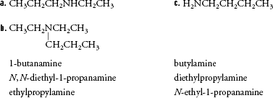
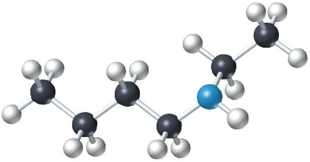
    - methylamine = CH₃NH₂
You Try It!
Match each IUPAC and common name to the correct structural formula:
Practice: Draw the line structure for the following compound, and then name it!

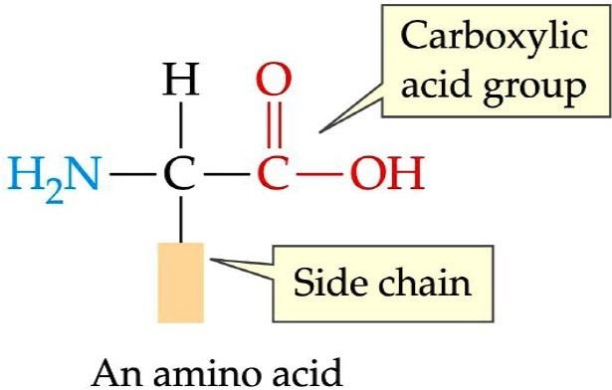
  - When NH₂- group is present as a substituent in a molecule it is called an group.
  - All proteins are made up of

.

Properties of Amines

  - on amines can hydrogen bond to water. (water solubility better than alkanes)

  - Primary and secondary amines can hydrogen bond to themselves and each other amines.

– As a result of hydrogen bonding, primary and secondary amines have

than alkanes of similar size.

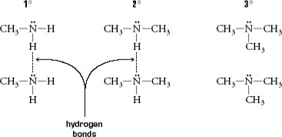
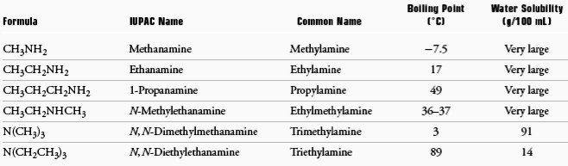

  - Volatile amines have strong .
-Amines smell like rotten fish.

  - Many amines are physiologically active.
-Smaller amines are irritating to the skin, eyes, and mucous membrane and are toxic by ingestion.

Heterocyclic Nitrogen Compounds
Rings that contain atoms other than carbon are known as .
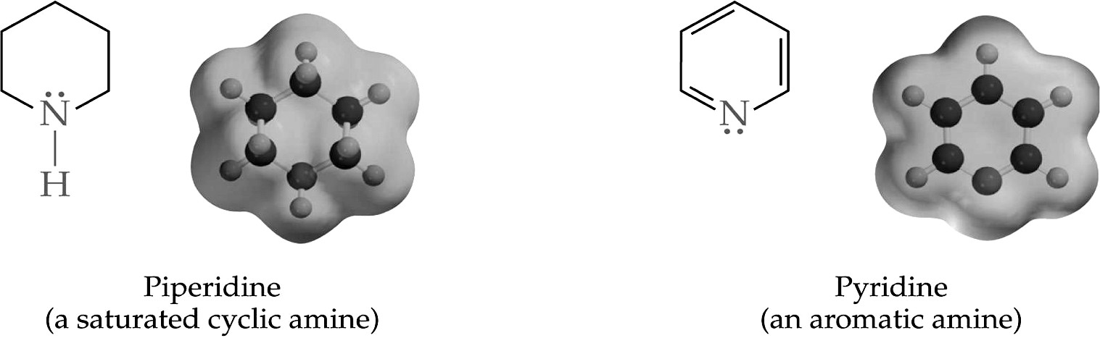

Heterocyclic rings are very common in natural compounds found in plants and animals.

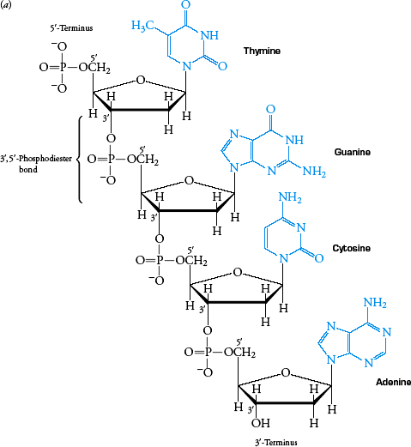
Example (left): DNA

Reactions of Amines

Reactions of Amines with Water

Amines are .

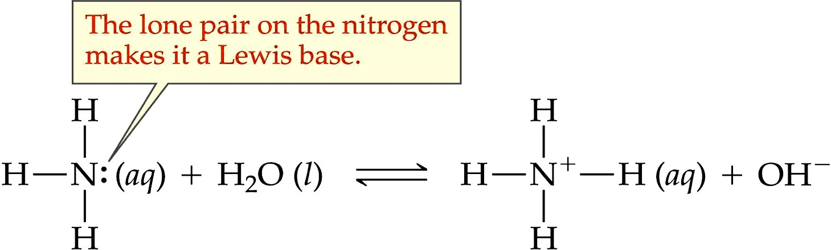
  - This basic property is due to the electron lone pair on the amine nitrogen that can be used to form a covalent bond with a H⁺ ion from water or an acid.

Amines react with water to form

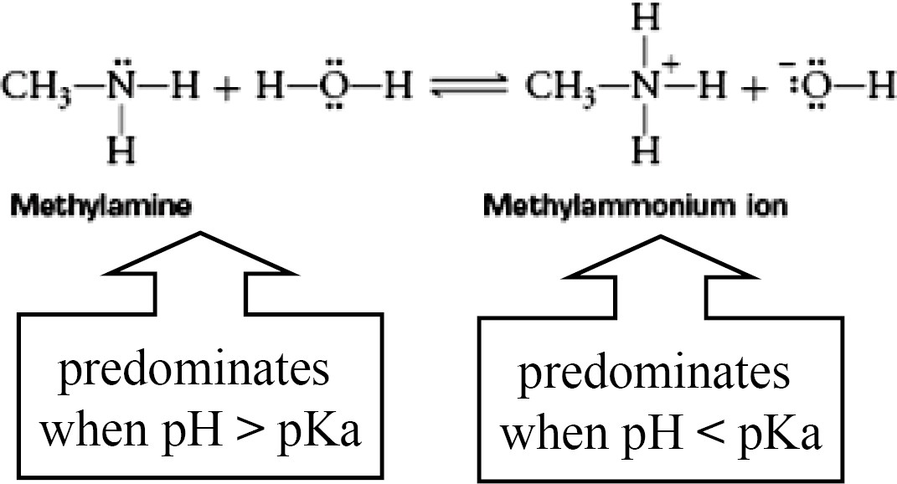
and OH⁻.

Reactions of Amines with Acid
A converts an amine into its conjugate acid. (pH<pK_{a})
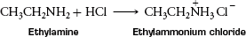
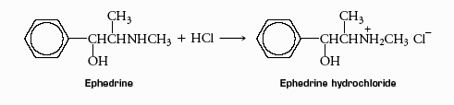

Amines in Plants: Alkaloids
- are naturally occurring nitrogen compounds isolated from plants.

- Most alkaloids are usually bitter-tasting, physiologically active, and in high doses.

- Some alkaloids are very familiar, such as the stimulants caffeine and nicotine.

- Other alkaloids are used as pain killers, sleep inducers, and for the creation of euphoria.

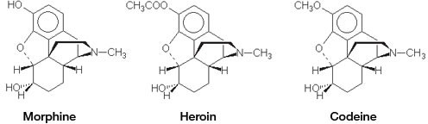

Amides
Amides result when the –OH from a carboxylic acid is replaced with an –NH₂ or an .
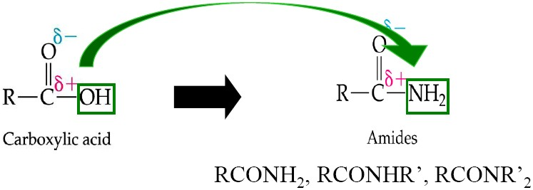

Amides contain an –NH₂ group with none, one, or both of the N-hydrogens replaced with alkyl groups (R).
  - Examples:
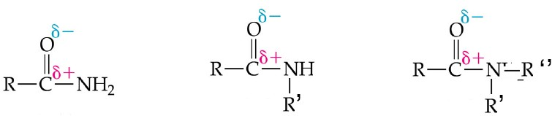

Naming Amides
- Name is based on the longest continuous carbon chain that contains the carbonyl (C=O).
– Just like naming the carboxylic acids!
- Drop the “e” on the parent chain and add “amide”
- List the substituents as usual, making carbonyl-carbon #1
•
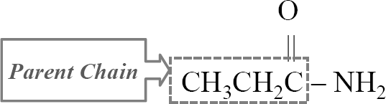
- Example:

Name:

You try one:
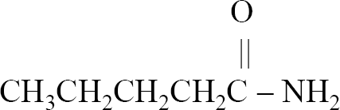
Name the compound shown below:

Name:

Formation of Amides
Amides can be made from and .

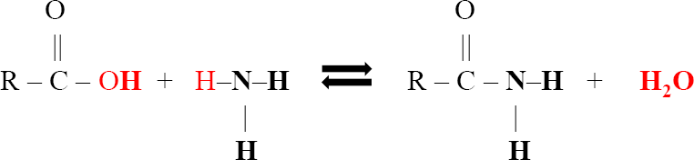
Examples:
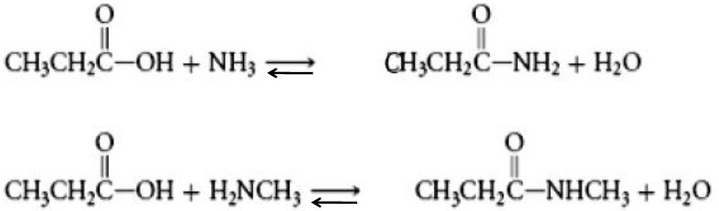

Note that the reaction is .

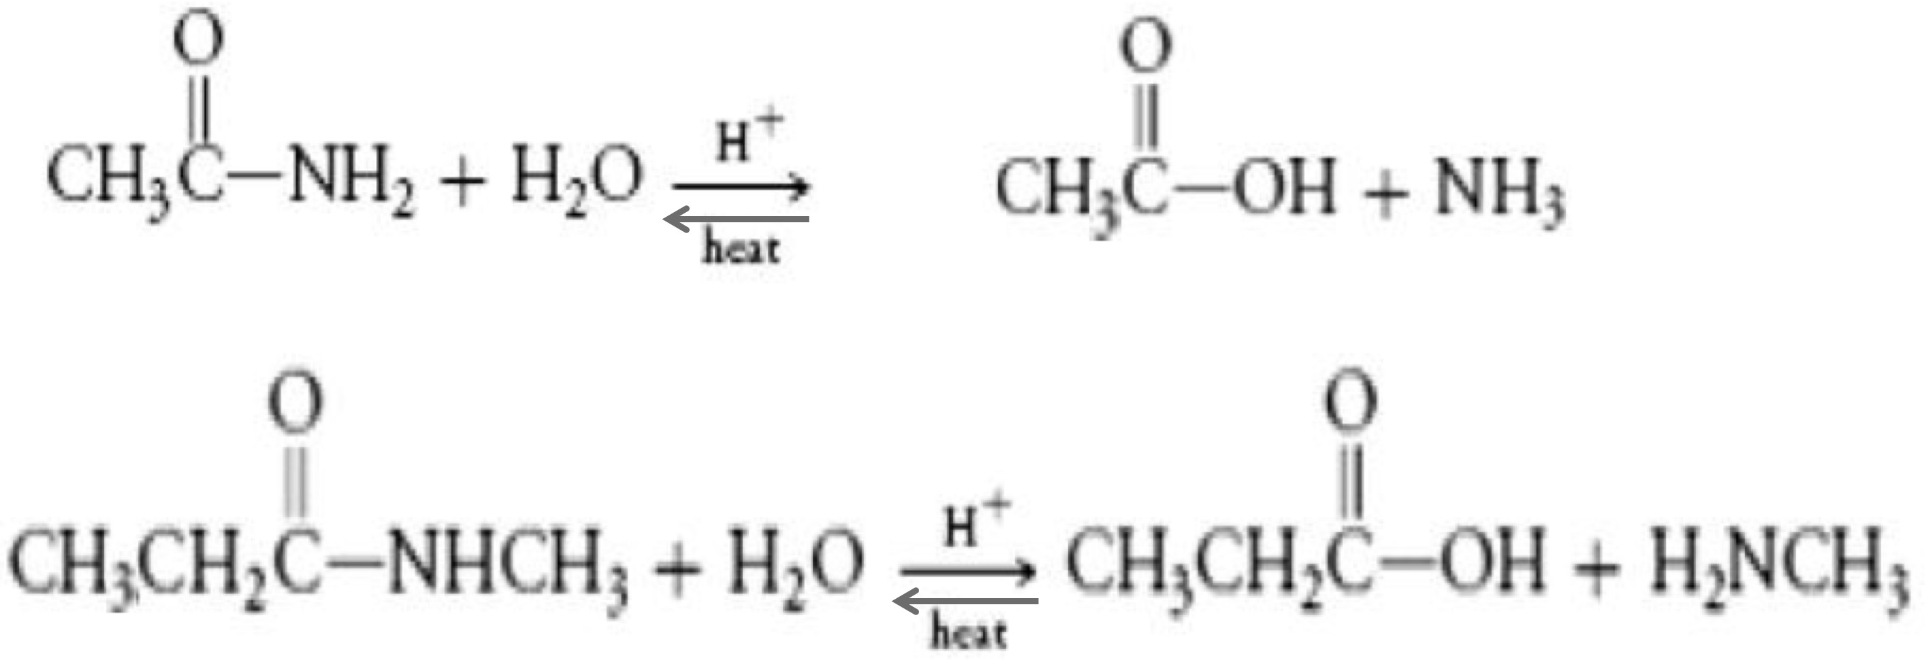

Definition:

Stereoisomers

- Stereoisomers are molecules that have the same formula and atomic connections, but different
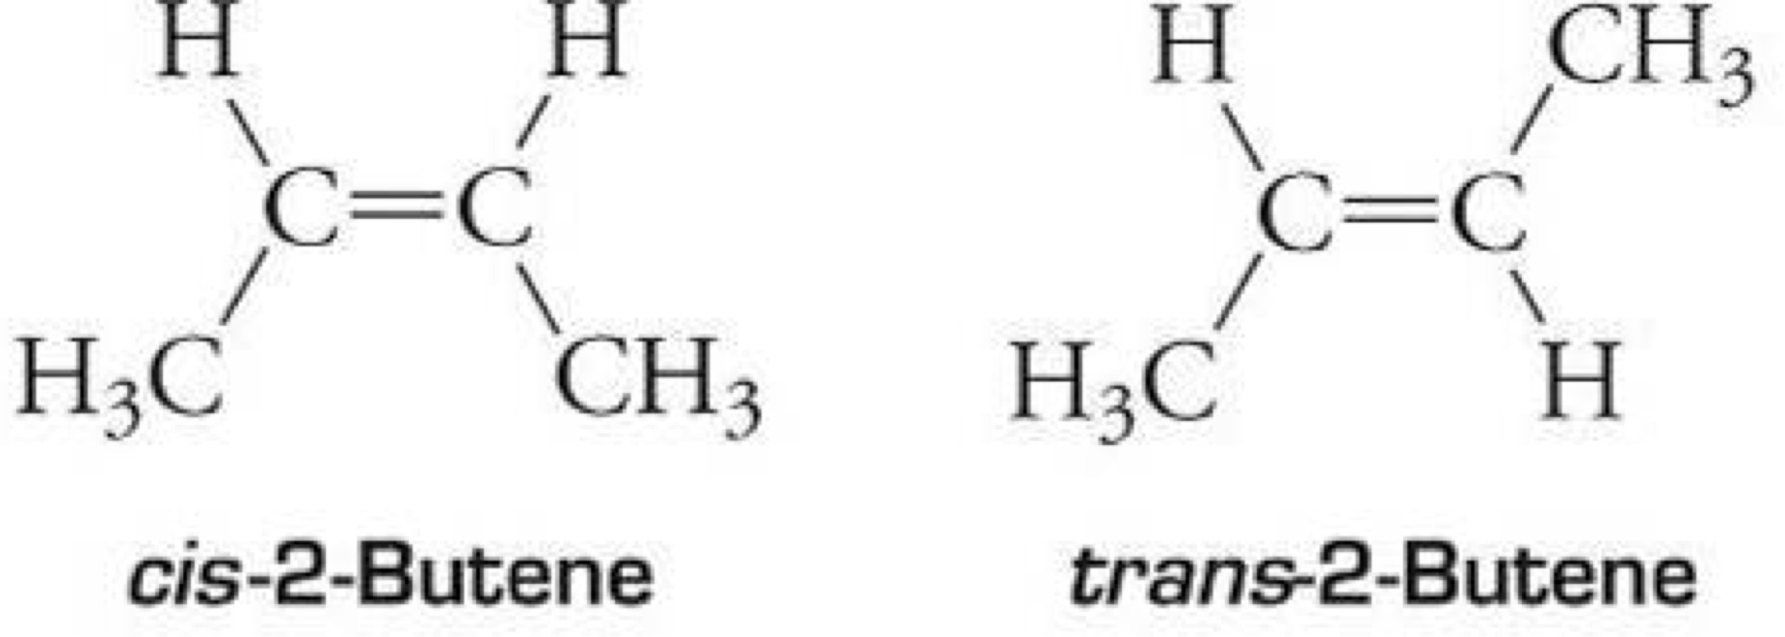
three dimensional shapes.
- We have seen some examples of stereoisomers in the past:
•
  - Geometric isomers (cis and trans)

We will learn about a new class of stereoisomers called .

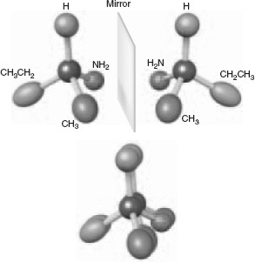
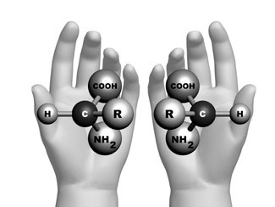
Enantiomers are nonsuperimposable mirror image molecules.
- The term chiral is used to describe objects that cannot be superimposed on their mirror image.
– Example: Your hands are chiral because your left hand is not superimposable on your right hand, its mirror image. (Try it!)

19

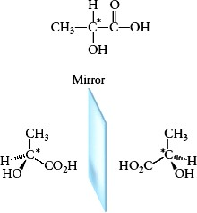
A carbon is chiral if it has different groups bonded to it!

You Try It! Use an asterisk (*) to label the chiral carbon(s) in each molecule.
  - Pairs of enantiomers are identical in almost every way.

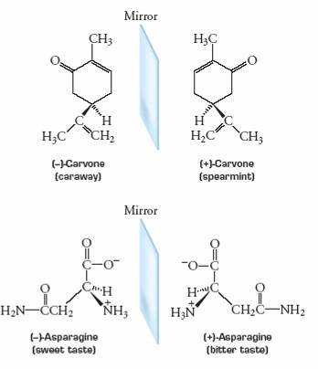
  - Biological systems such as smell and taste receptors, enzymes, and antibodies are selective with respect to enantiomers.

Molecules with More than One Chiral Carbon Atom

As the number of chiral carbon atoms in a molecule increases, so does the number of stereoisomers that can exist.
Number of stereoisomers = 2^{n}

where n is the number of carbon atoms.
You Try It!
- How many chiral carbon atoms does 2-bromo-3-chlorobutane have?
- How many stereoisomers are possible for this molecule?

Diastereomers
  - Stereoisomers that are not enantiomers (mirror images) are called .
